**Item 1**

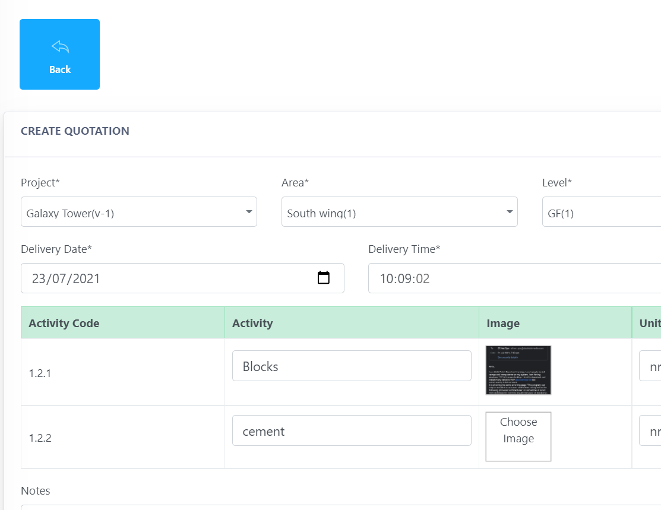

Can only upload image – ideally we want PDF and other files

**Item 2**

**Suppliers Management**

When Suppliers get email, click link -

